RESOLUTION NO.__________

RE: CERTIFICATE OF APPROPRIATENESS UNDER THE
PROVISIONS OF THE ACT OF THE PENNSYLVANIA
LEGISLATURE 1961, JUNE 13, P.L. 282 (53
SECTION 8004) AND BETHLEHEM ORDINANCE NO.
3952 AS AMENDED.

WHEREAS, it is proposed to install a hanging sign at 337 Vine Street.

NOW, THEREFORE, BE IT RESOLVED by the Council of the City of Bethlehem that a Certificate of Appropriateness is hereby granted for the work.

Sponsored by: (s)

(s)

ADOPTED BY COUNCIL THIS DAY OF

(s)
President of Council

ATTEST:

(s)
City Clerk

HISTORIC CONSERVATION COMMISSION

CASE # 599– It is proposed to install a hanging sign at 337 Vine Street
OWNER/APPLICANT: Gregory Heitman / Arlenis Diaz

The Commission upon motion by Mr. Cornish seconded by Ms. Starbuck adopted the proposal that City Council issue a Certificate of Appropriateness for the proposed work described herein:
- The proposal to install a hanging sign at 337 Vine Street was represented by Arlenis Diaz.

- The sign will be 36” x 18” and read “Empire Styles Boutique, Women Fashion Apparel”

- The lettering, border, and logo will be black and the background ivory.

- The sign will be fabricated of wood.

- It will hang from the existing scroll bracket.

- The motion to approve the proposal was unanimously approved.

CU: cu
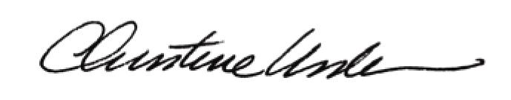

By:

Date of Meeting: November 21, 2016 Title: Historic Officer

